# File permissions in Linux

## Context

You work primarily with your research team. Part of your job is to ensure that the users on this team are authorized with the appropriate permissions. This helps keep the system secure.

Your task is to examine the existing permissions on the file system. You will need to determine if the permissions match the authorization that should be given. If they do not match, you will need to modify the permissions to authorize the appropriate users and remove any unauthorized access.

## Project description

The permissions of the users of the Human Resources Work Team of the company XXXXX will be checked.

To do this, chmod and ls commands will be used to verify that the permissions are correct.

We will have root permission to the directory: */home/researcher2*

To manage changes in user permissions

## Check file and directory details

[Add content here.]

Once inside the terminal, we proceed to review the contents of the /home/researcher2 directory

We note that the "research_team" user group itself is a hidden file for regular users, it can only be accessed as root, allowing write, read and execute changes.

The research team directory also has several hidden text files, to which the user "researcher2" can make read and write changes. Any other user can read this file but not make write or execute changes.

The user "researcher2" is included in a workgroup called " researcher_team"

There is a "projects" folder that has read, write and execute permissions for the user "researcher2", read and write for the group to which this user belongs.

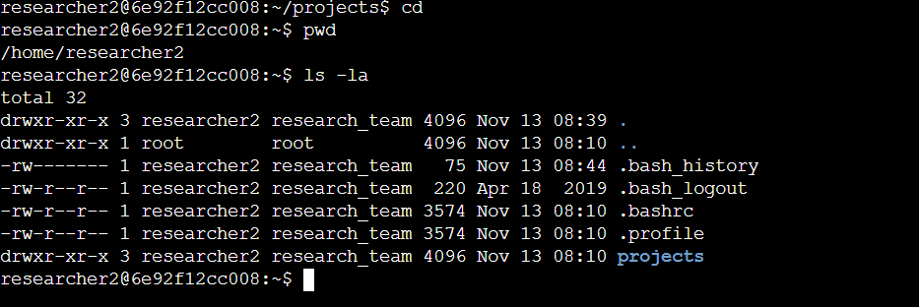

to visualize it better: (Only common files are shown, not hidden files)

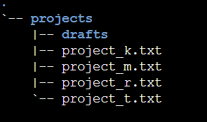

Inside the "Drafts" folder we find two more directories: both directories are hidden

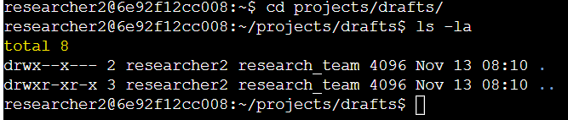

So once we have gone through the contents of the directory to be investigated, let's focus on changing the permissions. The mission is to leave the correct permissions on the "projects" folder. Currently these are the folder permissions:

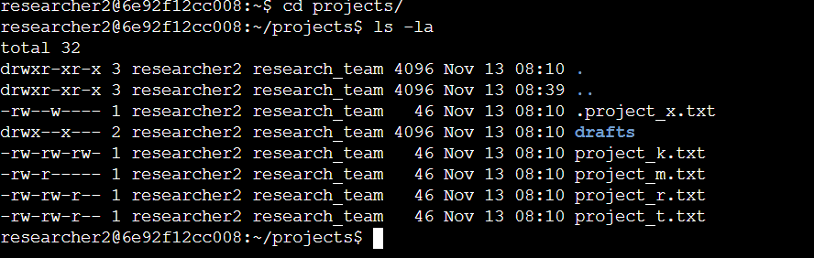

We will focus on access and permissions of .txt files

We were given the task of not allowing other users to make changes (write) to any of the files. To do this we made permission changes with the chmod command

## Describe the permissions string

[Add content here.]

We currently have the files with the following permissions:

| Name file | Permissions | Which means what can the user do in this file |
| --- | --- | --- |
| .project_x.txt (hidden file) | -rw--w---- | user can read, write . Group can write. Others not access |
| project_k.txt | -rw-rw-rw- | user can read, write . Group can read,write. Others can read, write |
| project_m.txt | -rw-r----- | user can read, write. Group can read. Others have no access |
| project_r.txt | -rw-rw-r-- | User can read and write. Group can read and write. Others can read |
|  |  |  |

## Change file permissions

*The organization does not allow other people to have write access to any file*.

Then, using *chmod*, we remove the write permission from the group "Others", from the group "research_team" and the user "research2" will keep the permission, since he is the author of the file. The permissions table will look like this:

| Name file | Permissions | Which means what can the user do in this file |
| --- | --- | --- |
| .project_x.txt (Hidden file) | -rw--w---- | user can read, write . Group can write. Others not access |
| project_k.txt | -r-r-r- | user can read, write . Group can read,write. Others not access to write |
| project_m.txt | rw-r----- | user can read, write. Group can read. Others have no access |
| project_r.txt | -rw-rw-r-- | User can read and write. Group can read and write. Others can read |
| Name file | Permissions | Which means what can the user do in this file |

The commands used to change write permissions on the files:

Command used *chmod o-w project_k.txt*

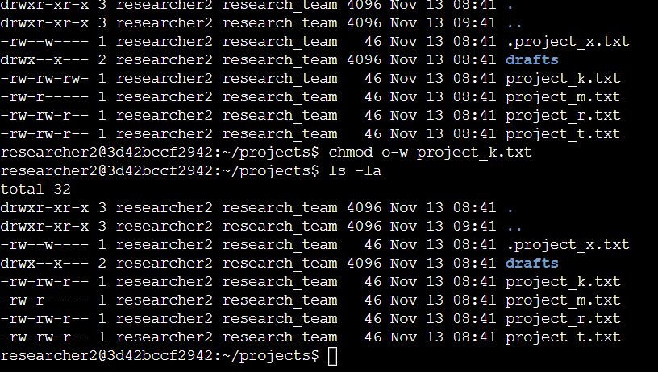

## Change file permissions on a hidden file

The project_m.txt file is restricted and should not be readable or writable by anyone, not even the group. Currently the research team group has read access, so we changed that.

Using *Chmod g-r project_m.txt*

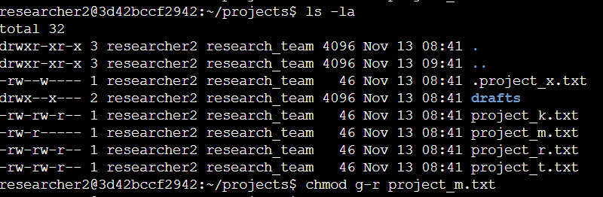

As you can see, now the restricted file projects_m.txt no longer has read, write or execute permissions for the group or for others.

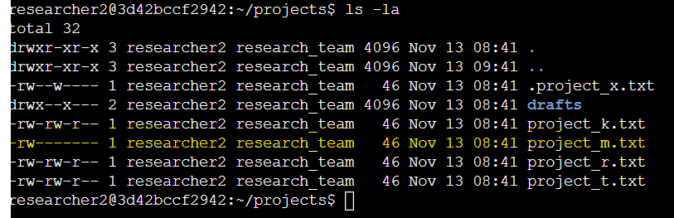

## Change directory permissions

Only the user *researcher2* should be able to access the drafts directory and its contents. (This means that only *researcher2* should have execute permissions)

Then we remove the permission from the group resarch_team, which currently has that permission.

Using the chmod command we change the permission of the directory for the "drafts" group in this way: *chmod g-x drafts*

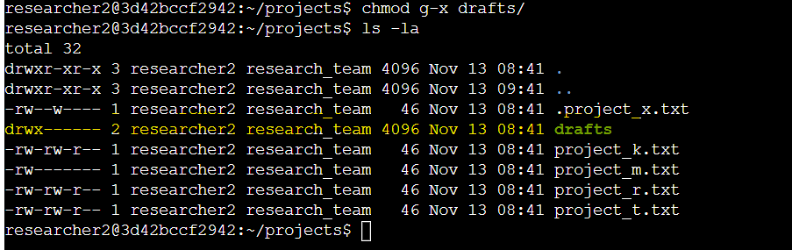

Finally, the research team has archived .project_x.txt, so it is a hidden file. This file should not have write permissions for anyone, but the user and group should be able to read the file. Use a Linux command to assign .project_x.txt the appropriate permission.  
The commands used were : chmod u-w, g-w, w+r .project_x-txt

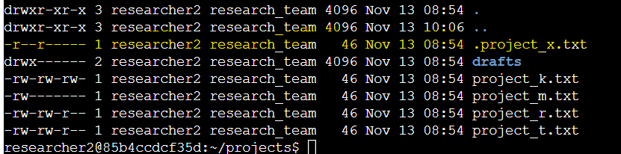

## Summary

By going through the assigned directories to establish the permissions requested for the user researcher2, access to other users to the project folder of the target group is finally restricted and the permissions for the group of other users, the target work group and the user who owns the directory are specifically specified.

# Current file permissions

This document displays the file structure of the /home/researcher2/projects directory and the permissions of the files and subdirectory it contains.

In the /home/researcher2/projects directory, there are five files with the following names and permissions:

* project_k.txt
  + User = read, write,
  + Group = read, write
  + Other = read, write
* project_m.txt
  + User = read, write
  + Group = read
  + Other = none
* project_r.txt
  + User= read, write
  + Group = read, write
  + Other = read
* project_t.txt
  + User = read, write
  + Group = read, write
  + Other = read
* .project_x.txt
  + User = read, write
  + Group = write
  + Other = none

There is also one subdirectory inside the projects directory named drafts. The permissions on drafts are:

* User = read, write, execute
* Group = execute
* Other = none